Theory question

1.

Start condition:

I want to see a movie.

I have time and money for a movie.

Roles:

Watchers, ticket seller, ticket inspector, projectionist

Props:

Seats, tickets, screen, camera, money, sound equipment

Scenes:

1. buy ticket: I go to movie theater and wait in line; I give money to the seller; Seller gives me ticket
2. get in: I give ticket to the inspector; The inspector let me in; I get in and find my seat
3. watch movie: movie start; I watch; movie ends
4. out: The spotlight is on; I leave

result: I am happy; I spend money; theater receives money; box office increases

2. 带鸭去对岸，空手回，带狼去对岸，带鸭回，带玉米去对岸，空手回，带鸭去对岸。

3. 写式子之前，找准重点要素，正式开始时可忽略不重要因素，提高效率。

4. ABCDEFHGK (BFS) ABCEFDHI(DFS)

5.

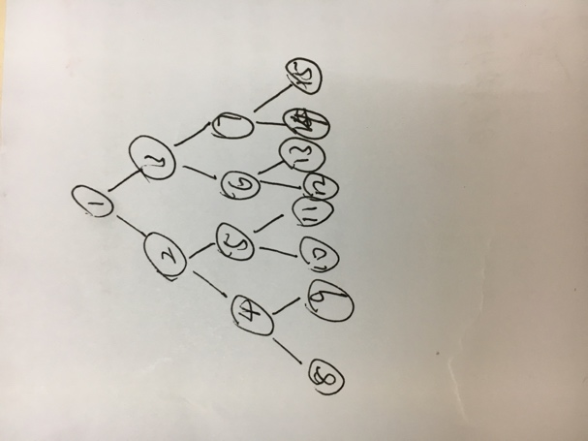

BFS: 123456789 10 11 DFS: 124895 10 11 It: 1 123 1245367 1234895 10 11

很有效,向下出度为2， 向上为1

从目标出发访问上一代直到根部

将目标数字写成二进制形势，从第二位开始，0则向左，1则向右，即为路径。